**Report on Replacement and Performance Analysis of JK_BD4A24S4P JK BMS**

* **Revision Number:**  
  Rev. 1.0
* **Date of Creation or Update:**  
  20/12/2024
* **Prepared By:**  
  Maria Tabasum Shoaib(Firmware Engineer)
* **Reviewed By:**
* **Approved By:**

**Table of Contents**

1. **Introduction**
2. **Overview of the Replacement Process**
3. **Steps Undertaken**
4. **Observations and Results**
5. **Comparison of Performance**
6. **Recommendations and Conclusion**

**Report on Replacement and Performance Analysis of JK_BD4A24S4P JK BMS**

**1. Introduction** This report documents the replacement of a faulty JK_BD6A24S-8P Battery Management System (BMS) with a JK_BD4A24S4P BMS. The new unit was tested for performance using both the mobile application and RS485 communication protocol. The report details the steps taken during the replacement process, the tests conducted, and the observations confirming that the new BMS is functioning as expected.

**2. Overview of the Replacement Process**

**2.1 Background**

* **Faulty BMS Model:** JK_BD6A24S-8P
* **Replacement BMS Model:** JK_BD4A24S4P
* **Battery Specifications:** 72V, 30A
* **BMS Specifications:** 40A

**2.2 Reasons for Replacement:** The JK_BD6A24S-8P BMS was found to be faulty due to missing cell voltage readings for cells 3, 11, and 19. These issues resulted in inconsistent data responses during communication.

**3. Steps Undertaken**

**3.1 Removal of Faulty BMS**

* The JK_BD6A24S-8P BMS was safely disconnected from the battery.
* Wiring connections were inspected for any potential issues before installing the replacement unit.

**3.2 Installation of Replacement BMS**

* The JK_BD4A24S4P BMS was installed, ensuring proper connections to all cells and components.
* Initial setup was performed to match the battery configuration and ensure compatibility.

**3.3 Initial Testing**

* A preliminary check was conducted to verify power-on functionality and communication readiness.

**4. Observations and Results**

**4.1 Mobile Application Testing**

* The BMS was paired with its proprietary mobile application.
* All cell voltages were displayed accurately.
* Parameters such as state of charge (SOC) and temperature were consistent with expected values (shown in Fig. 1).

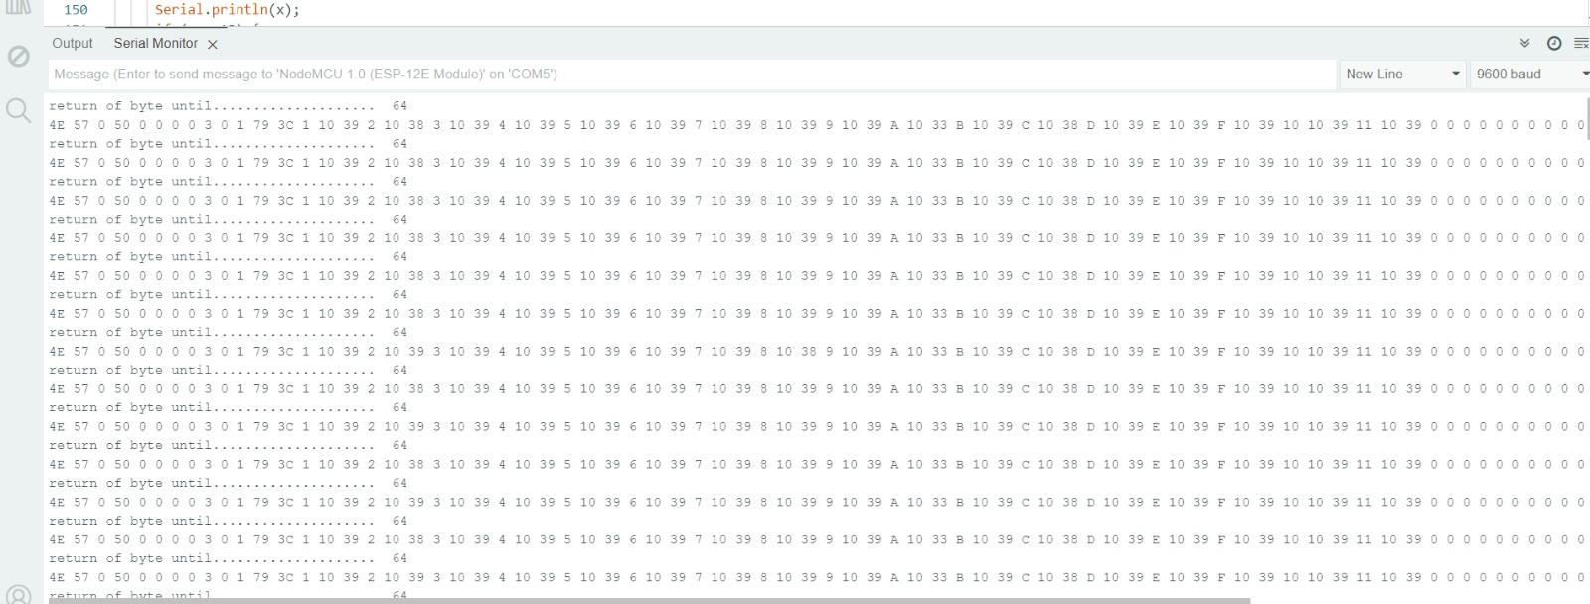

Figure 1: Data received from JK BMS

**4.2 RS485 Communication Testing**

* Commands were sent via the RS485 interface to retrieve various data parameters.
* The BMS responded consistently, providing accurate data for all requested parameters.
* No disruptions or inconsistencies were observed during communication.

**4.3 Overall Performance**

* The JK_BD4A24S4P BMS demonstrated stable operation throughout the testing phase.
* The system exhibited reliability in both data acquisition and real-time monitoring.

**5. Comparison of Performance**

| **Parameter** | **JK** **_BD6A24S-8P (Faulty)** | **JK_BD4A24S4P (Replacement)** |
| --- | --- | --- |
| Cell Voltage Display | Missing for 3, 11, 19 | All cells displayed |
| RS485 Communication | Inconsistent responses | Stable and consistent |
| Mobile App Data | Partial | Complete |
| Overall Reliability | Low | High |

**6. Recommendations and Conclusion**

**6.1 Recommendations**

* Continue using the JK_BD4A24S4P BMS for this battery setup.
* Perform periodic maintenance and checks to ensure the BMS continues to function reliably.
* Keep logs of RS485 communication data for future reference and troubleshooting.

**6.2 Conclusion** The replacement of the faulty JK_BD6A24S-8P BMS with the JK_BD4A24S4P model was successful. The new BMS has been tested thoroughly and confirmed to be working as expected. Both mobile application and RS485 communication tests showed consistent and accurate results. This replacement has resolved the previous issues and restored the reliability of the battery management system.